ENGINEERING OF PHYSICS
MECHANICAL PHYSICS LABORATORY II
EXPERIMENT NAME: MAGNETIC FIELD-ELECTROMAGNETIC INDUCTION-PRINCIPLES OF GENERATORS AND MOTORS
EXPERIMENT NO: 6-7-8
STUDENT NAME SURNAME:
STUDENT NUMBER:
DEPARTMENT&EDUCATION TYPE:

EXP6: MAGNETİC FIELD
- Draw the magnetic field lines of the bar and U magnets
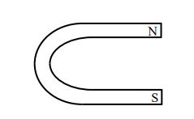

EXP7: ELECTROMAGNETIC INDUCTION
- Illustrate the direction of the current into the galvanometer.
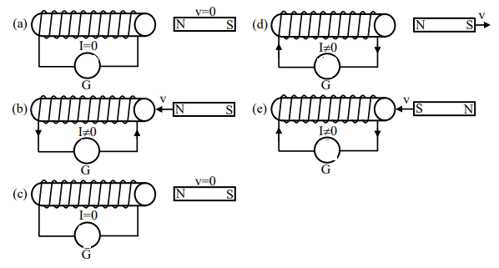

EXP8: PRINCIPLES OF GENERATORS AND MOTORS
Answer the questions.
- Formed when a wire in an electric circuit is wrapped around an iron core producing a magnetic field
- Electromagnet
- Generator
- Motor
- Bar Magnet
- Produces an electric current when a coil of wire wrapped around an iron core is rotated near a magnet
- Car
- Generator
- Motor
- Magnet
- Changes electrical energy to mechanical energy.
- Magnet
- Simple Electric Motor
- Generator
- Car
- In a simple electric motor, like poles of the magnets repel and unlike poles of the magnets attract. This causes the coil to rotate and thus changes electrical energy to ________________energy
- Chemical
- Mechanical
- Sound
- Light
- Surrounding a magnet is a __________________ that applies a force, a push or pull, without actually touching an object.
- Coil
- Magnetic Field
- Car
- Circuit

